A000-Afr-D R Congo-Mangbetu Jar-Terracotta-19th c

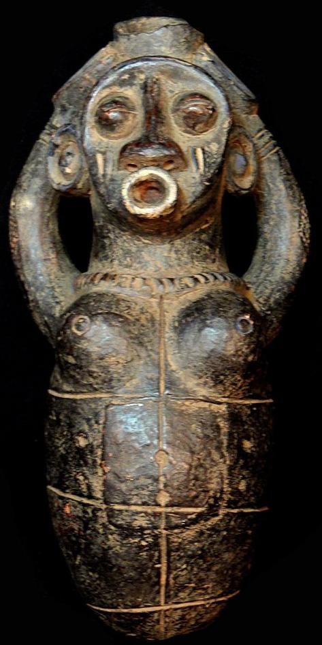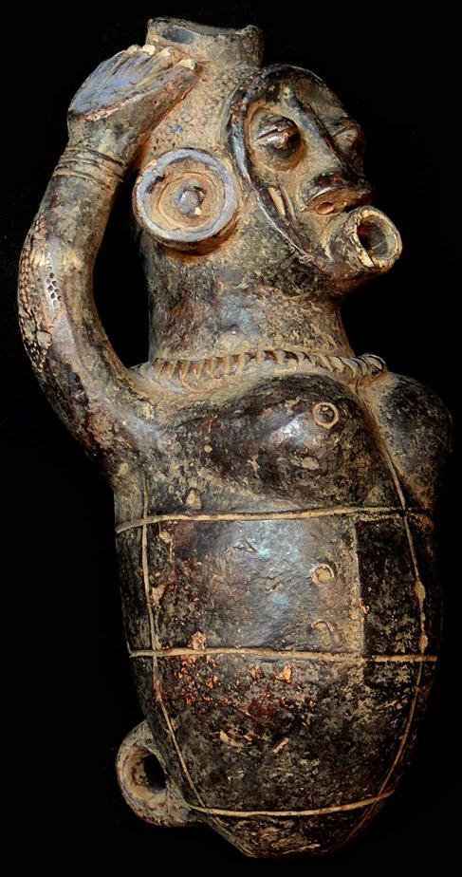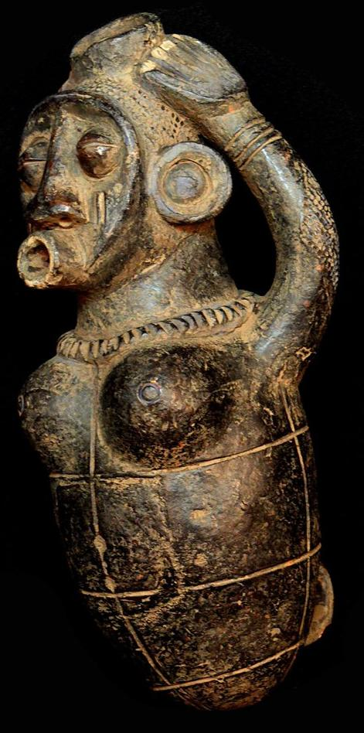

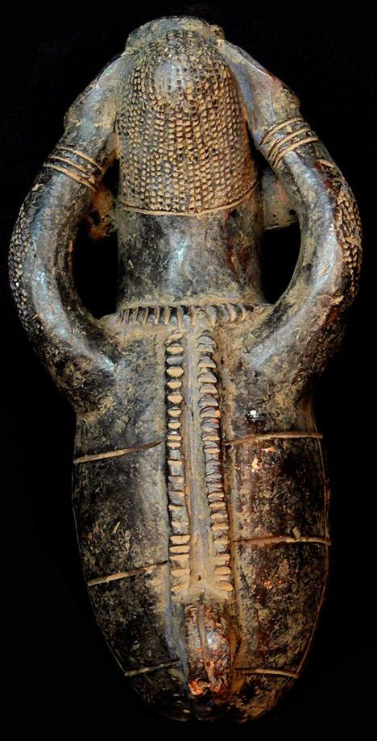

Figs. 1-4. Afr-D R Congo-Mangbetu Jar-Terracotta-19th c

Case No.: 6

**Accession No.**

**Formal Label:**

**Display Description:**

Magnificent Mangbetu jar with high quality 19th c earthenware. It was used by those pharmacists in treating persons in need of pain management. . Named the “expansive” in D R Congo, these ceramic containers were filled with palm wine and other pain depressants to zone in on centers of pain. Correspondingly, the high patina is very suggestive of many years of medical use. 

**LC Classification:**

**Date or Time Horizon:**

**Geographical Area:**

**Map:**

**GPS coordinates:**

**Cultural Affiliation:**

**Media:**

**Dimensions:**

**Weight:**

**Condition:**

**Provenance:**

**Discussion:**

**References:**

Mangbetu Jar

Origin: DRC Kongo  
Size : 10.236 inches  
Weight : 2.176 pounds  
Material: Terracotta